**Data Analysis Using Zoho Analytics**

Zoho Analytics is a powerful self-service business intelligence (BI) and data analytics tool that enables users to import, visualize, and analyze data with ease. Designed for both beginners and professionals, it provides automated insights, AI-powered analysis, and interactive dashboards to make data-driven decisions.

For threat intelligence and cybersecurity analysis, Zoho Analytics helps security teams track, visualize, and understand breach data trends. It allows analysts to identify high-risk regions, breach types, and affected individuals—providing critical insights to strengthen security strategies. With features like auto-generated reports, data blending, and predictive analytics, Zoho Analytics simplifies complex threat data analysis for organizations.

**Walkthrough**

In this walkthrough, we will import **HHSCyberSecurityBreaches.csv**, generate automatic reports, and analyze data related to individuals affected by breaches.

**Step 1: Access Zoho Analytics**

1. Go to [**https://www.zoho.com/analytics/**](https://www.zoho.com/analytics/).
2. Click **Sign Up Free** if you don’t have an account, or **Sign In** if you already have one.
3. Complete the registration process (if signing up) and log into the dashboard.

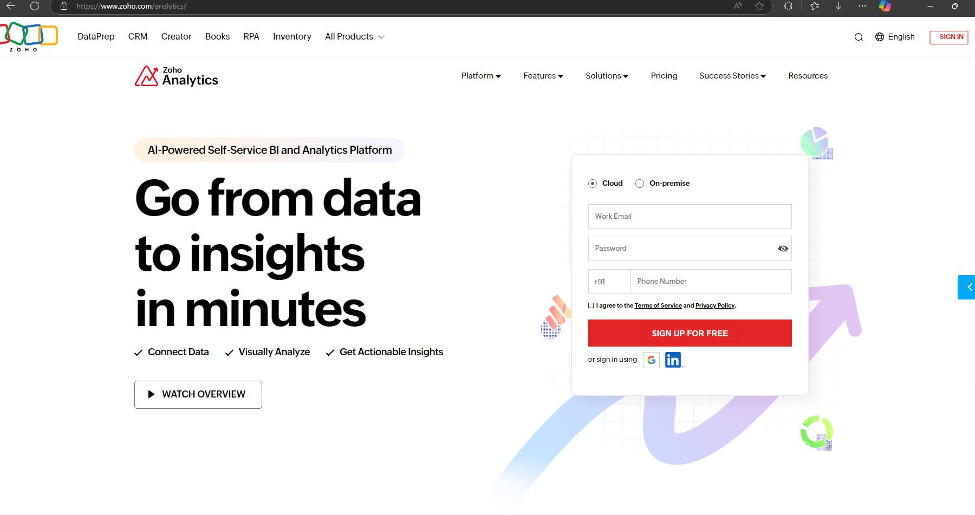

**Step 2: Importing the Data File**

1. Once Import Your Data page appears, click the Files & Feeds icon

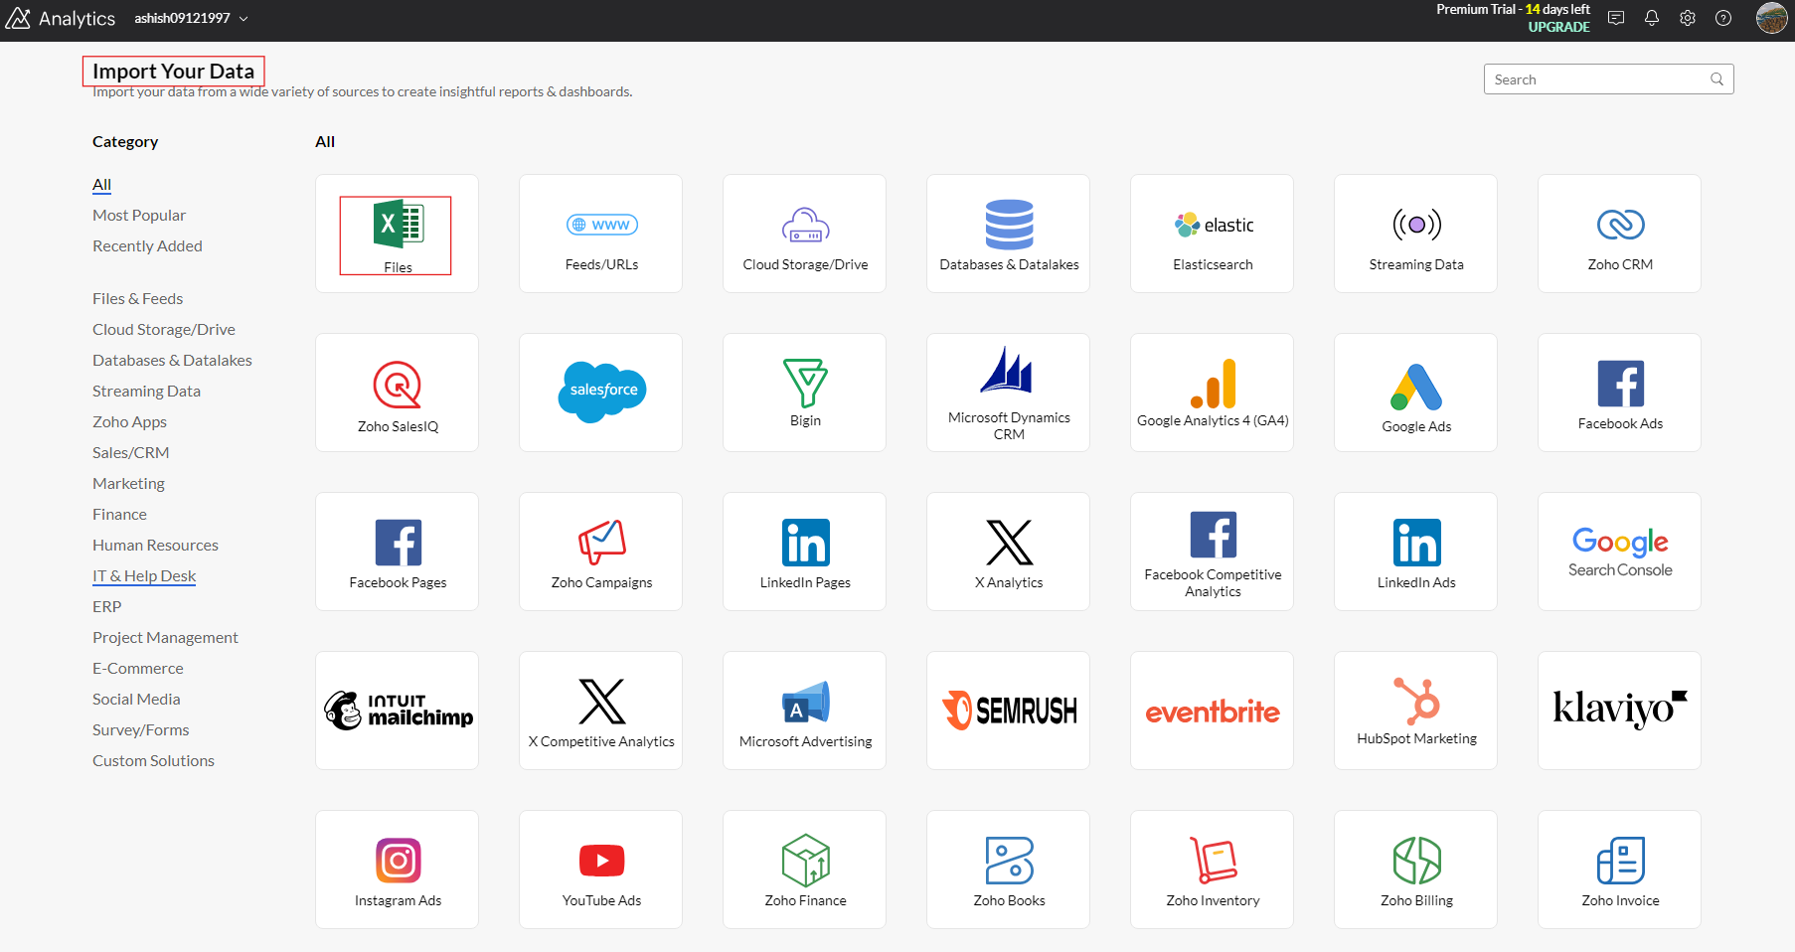

1. Enter a **Workspace Name** (Cybersecurity Breach Analysis).

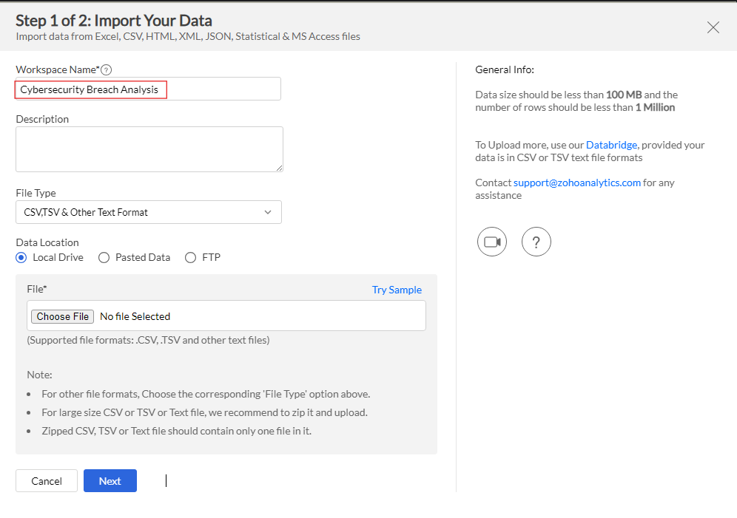

1. Click **Choose File** and select **HHSCyberSecurityBreaches.csv** from its saved location and Click on Next.

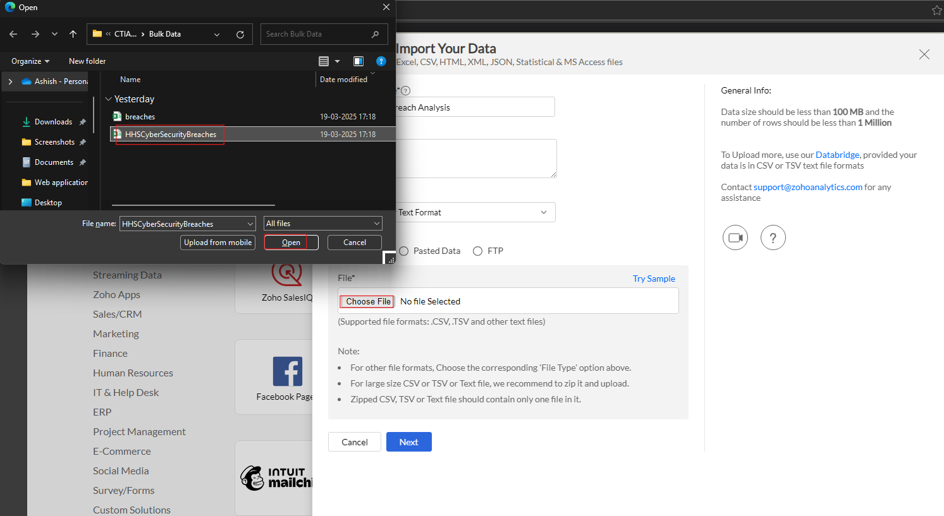

1. With the default settings, Click **Create** to upload and import the dataset.

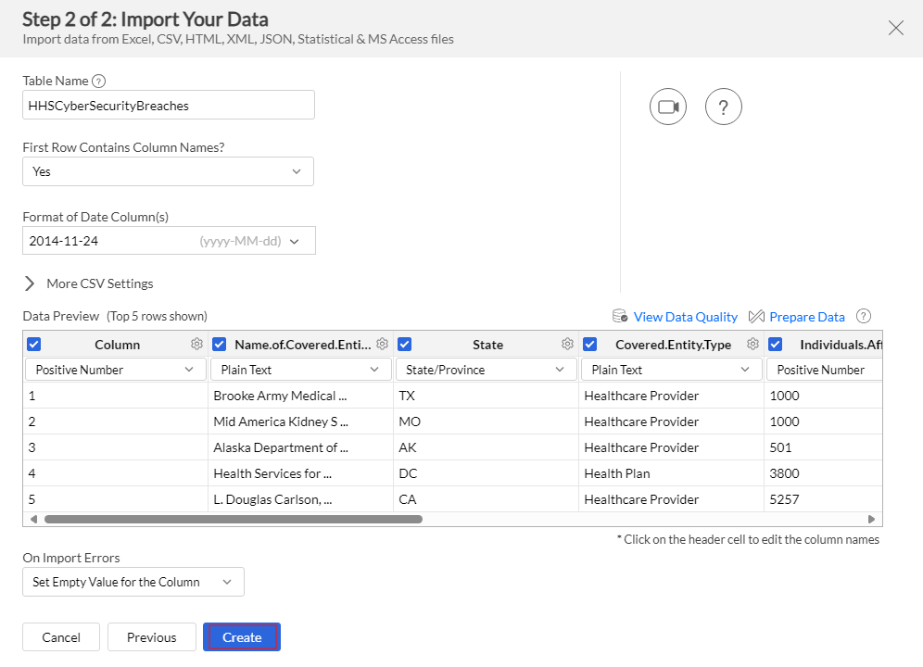

1. We have successfully imported. Click on Close button.

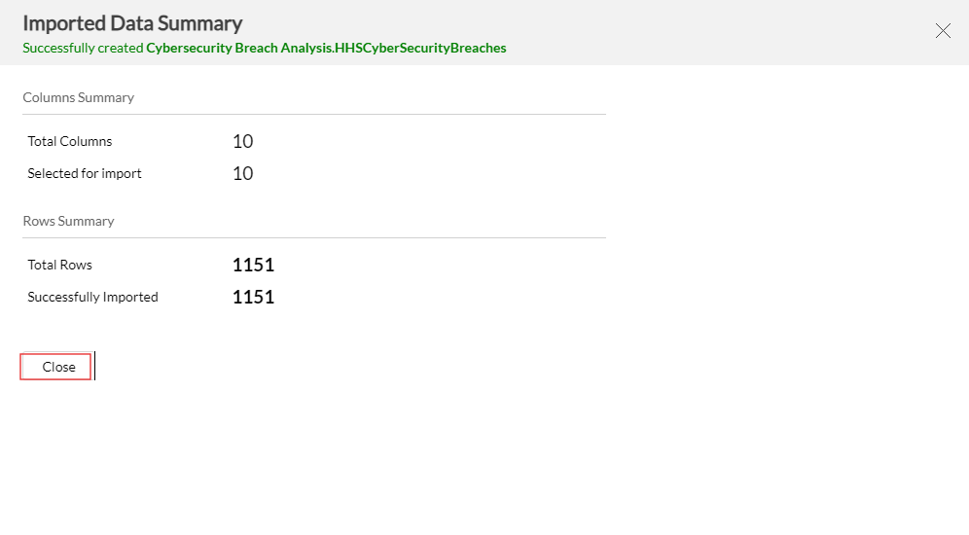

**Step 3: Save the Dashboard**

Once the data is imported:

1. Check for inconsistencies or formatting errors (if needed, clean the data).
2. Click **Auto Generate Reports** to let Zoho Analytics create reports automatically.

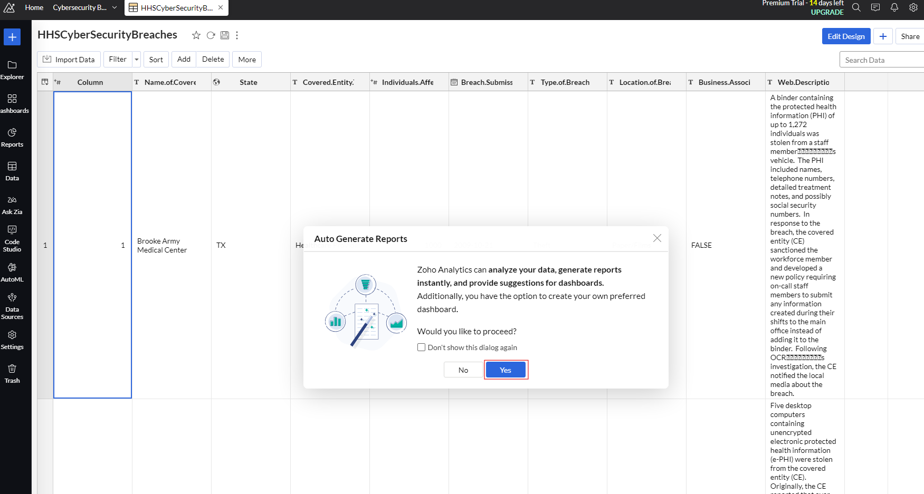

1. Click on **Individuals.Affected Analysis** Dashboard to view the preview. Click on Save Dashboard.

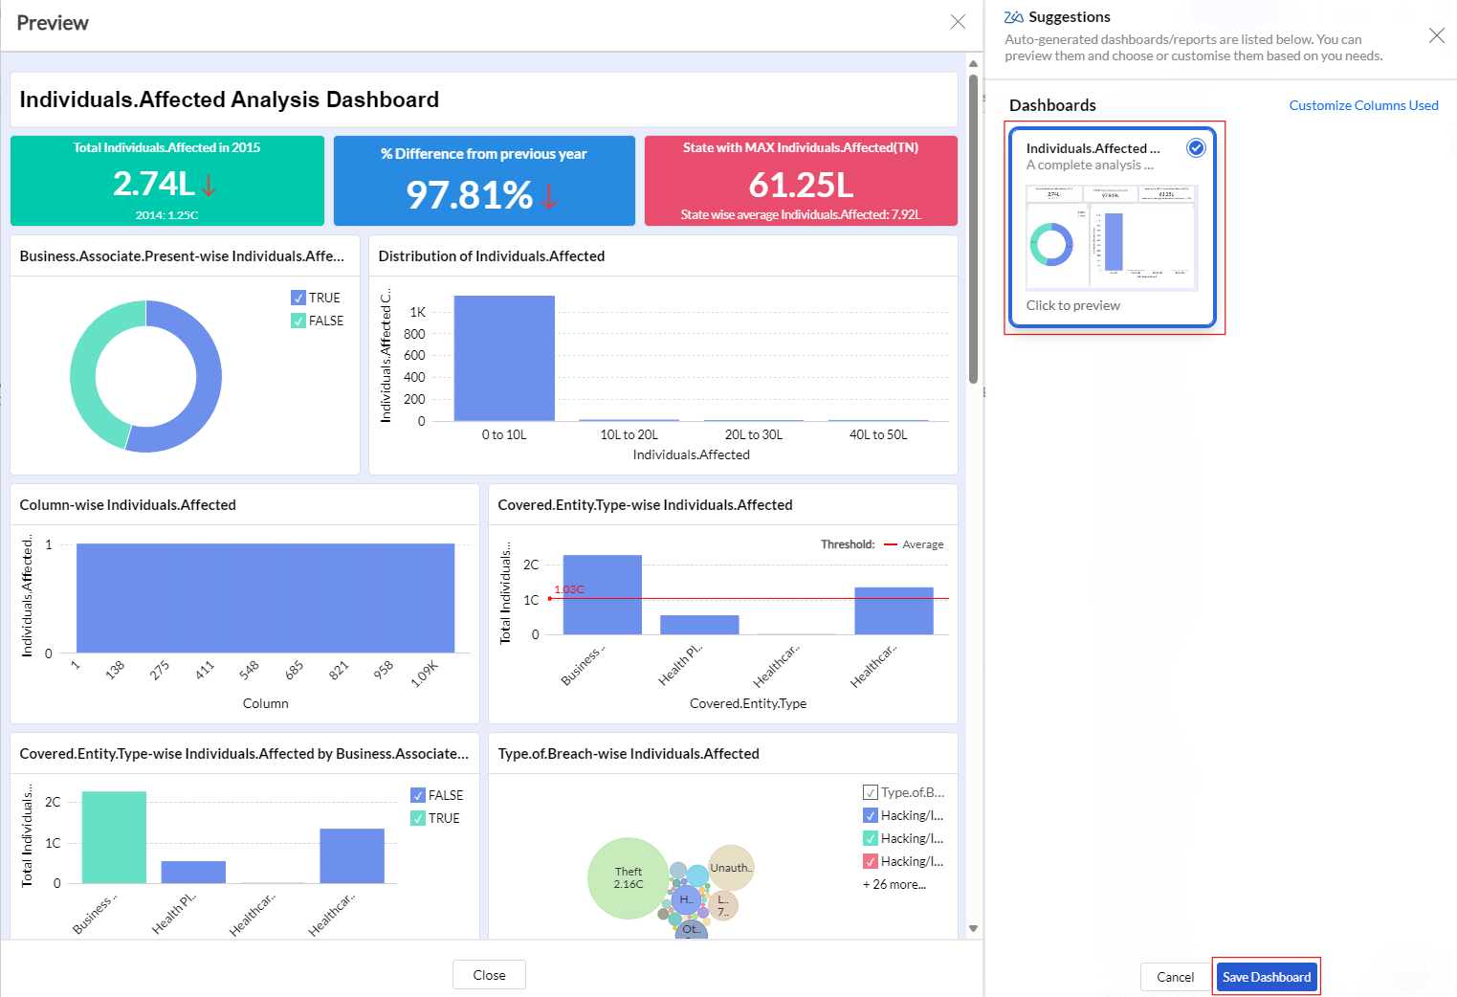

**Step 4: Analyzing Individuals Affected**

Let’s analyze individuals affected by data breaches. You can also double click on any Key Performance Indicators (KPIs) or Summary Metrics to view in full screen.

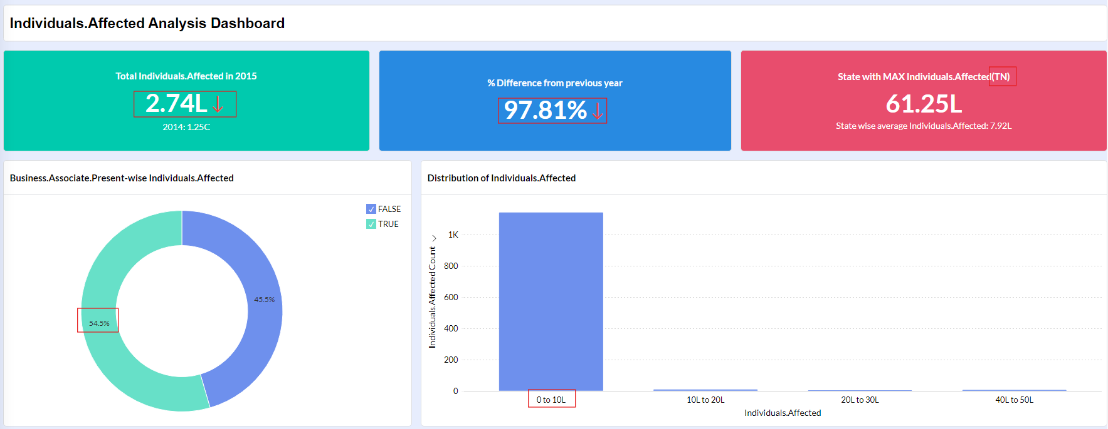

1. Total Individuals Affected in 2015: **2.74L** (274,000 people)
2. % Difference from Previous Year: Shows a **97.81% decrease** in affected individuals from 2014 to 2015.
3. State with MAX Individuals Affected: **TN - Tennessee**
4. Business Associate Presence-wise Individuals Affected: Business Associate (BA) refers to a third-party vendor, service provider, or contractor that handles, processes, or transmits sensitive data. **54.5% of breaches** involved a Business Associate (TRUE).
5. Distribution of Individuals Affected: The majority of incidents had **0 to 10L individuals** affected. Very few breaches resulted in higher numbers (10L-50L individuals).
6. Type-of-Breach-wise Individuals Affected: View the number of affected individuals per breach type in bubble chart.

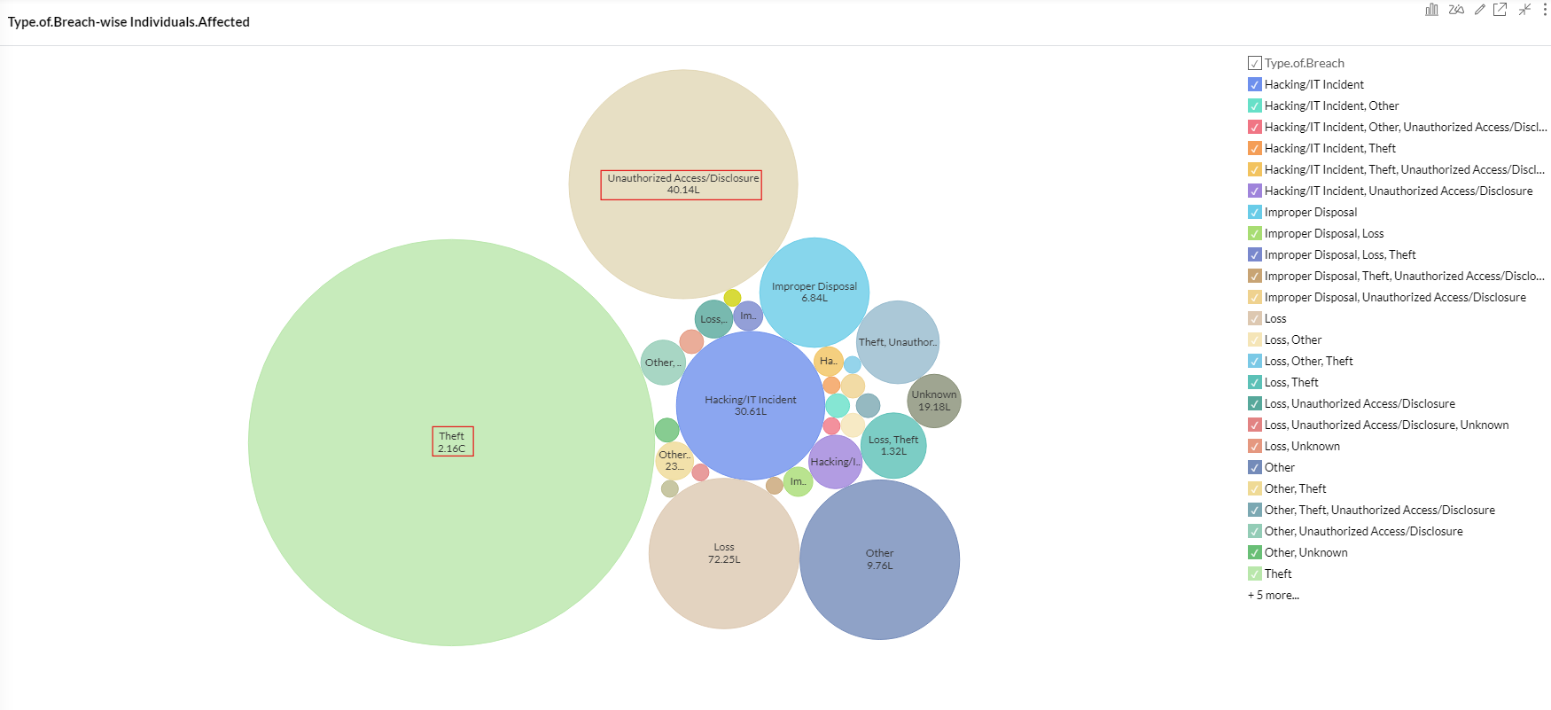

This chart helps identify the most common threats affecting individuals. Organizations should prioritize security investments based on which breach types cause the most impact. Encryption, access control, employee training, and compliance checks can reduce such incidents.

1. Running Individuals Affected Across Years: This line graph visualizes the cumulative number of individuals affected by data breaches over time (2009 - 2015).

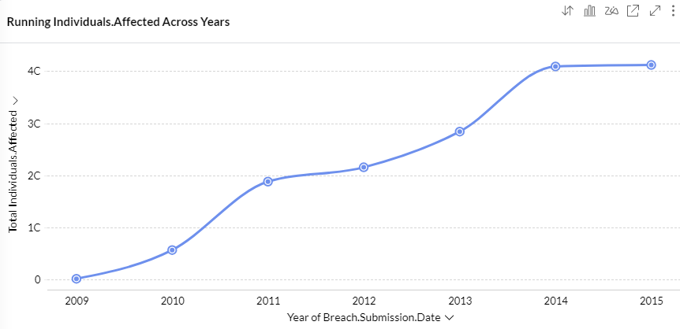

2013-2014 saw the largest surge, indicating severe cybersecurity incidents. The plateau in 2015 could be an anomaly or the result of improved security posture.

Threat intelligence teams should analyze what caused these changes and adapt strategies accordingly.

**Step 5: Exporting Report**

1. Click **Export button** and choose **Each Report in a New Page – PDF.**

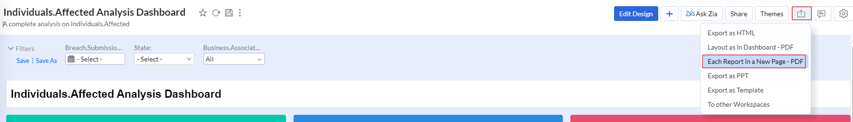

1. Click on Export button.

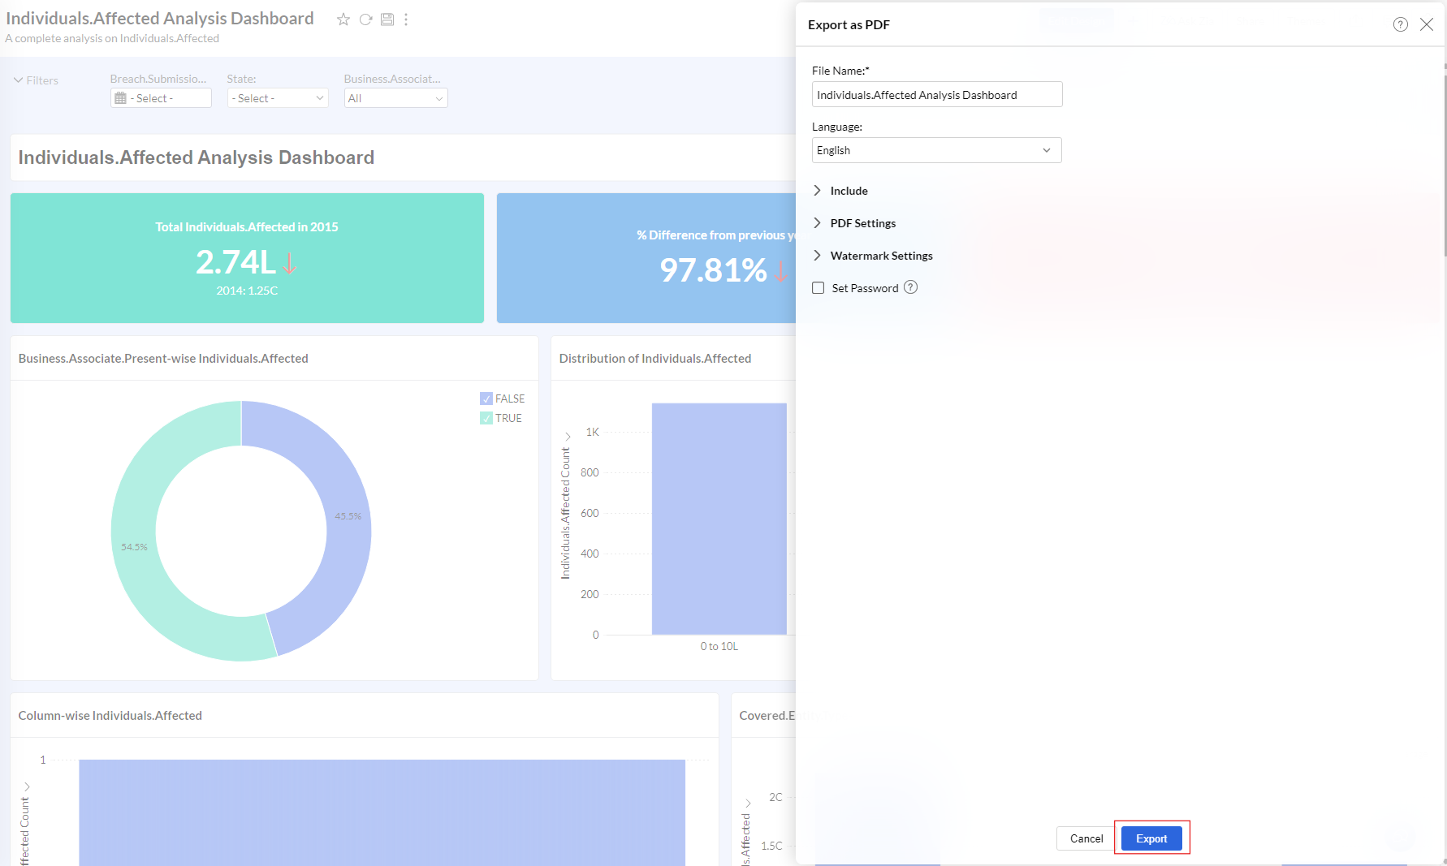

Report will be successfully downloaded.

**Conclusion**

Zoho Analytics is a versatile and user-friendly platform that empowers cybersecurity professionals to analyze large datasets efficiently, uncover security threats, and derive actionable intelligence. By leveraging its visual dashboards and automated insights, organizations can enhance their cybersecurity posture, monitor breach trends, and improve compliance measures. Whether for real-time monitoring or historical threat assessment, Zoho Analytics plays a crucial role in data-driven cybersecurity decision-making.